DTSC 671: AI Solutions in the Cloud

SUBMISSION TEMPLATE:
Text-to-Speech with Amazon Polly

Select File > Make a copy to edit the template and add your screenshots. Download the completed template as a PDF document to submit to Brightspace.

In every screenshot, include your AWS username that appears in the upper right corner. Example:

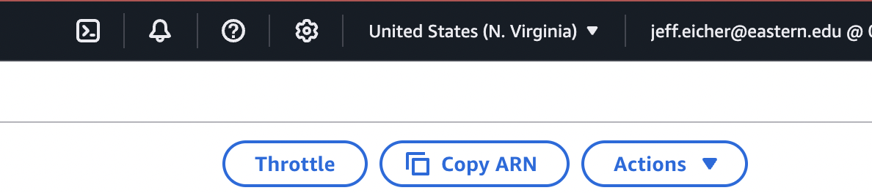

If any one screenshot is missing this identification, the entire assignment will be scored no higher than 70%.

Points totals are provided at the start of each question. You score either full credit or 0 points; there is no partial credit for each question.

Curtis Nielson
DTSC 671 – Amazon Polly

- [10 point] In the space below, provide the short text that you chose.

Stephen Hawking told the BBC, “The development of full artificial intelligence could spell the end of the human race. It would take off on its own, and re-design itself at an ever increasing rate. Humans, who are limited by slow biological evolution, couldn’t compete, and would be superseded.”

- [10 points] In the space below, provide a screenshot of the Lambda function diagram (with trigger and destination).

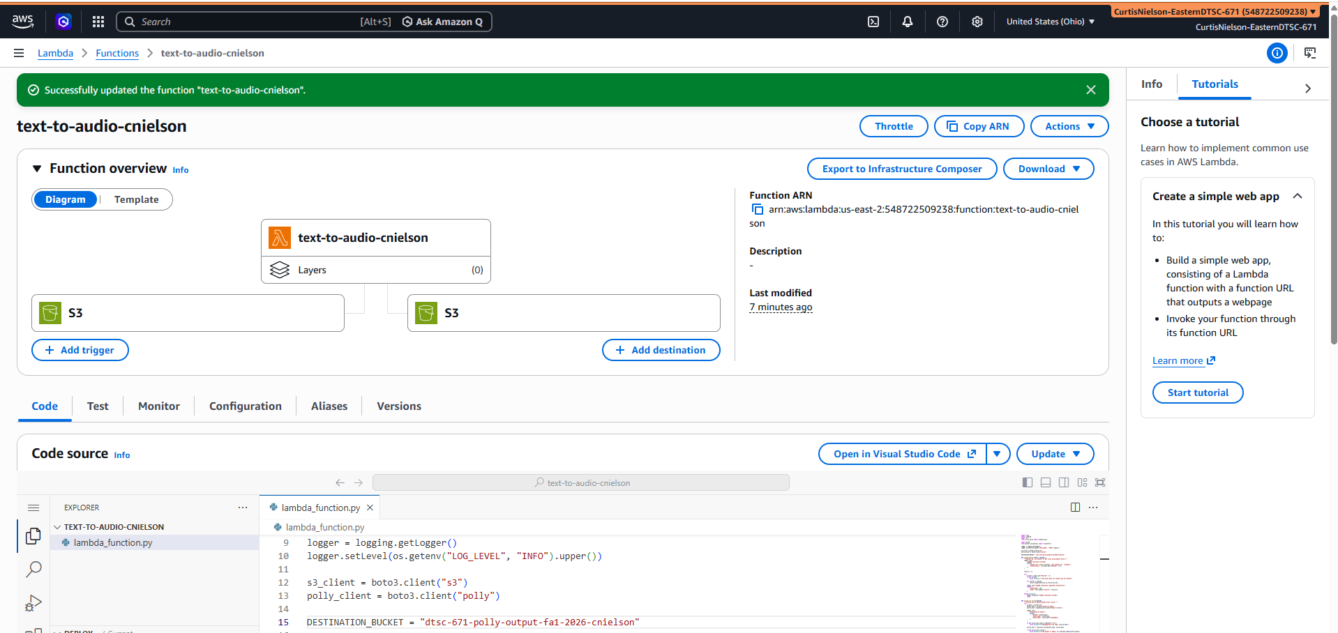

- [10 points] In the space below, provide both a screenshot of the beginning of your Lambda code with your account showing, then copy-paste your full lambda code below the screenshot.

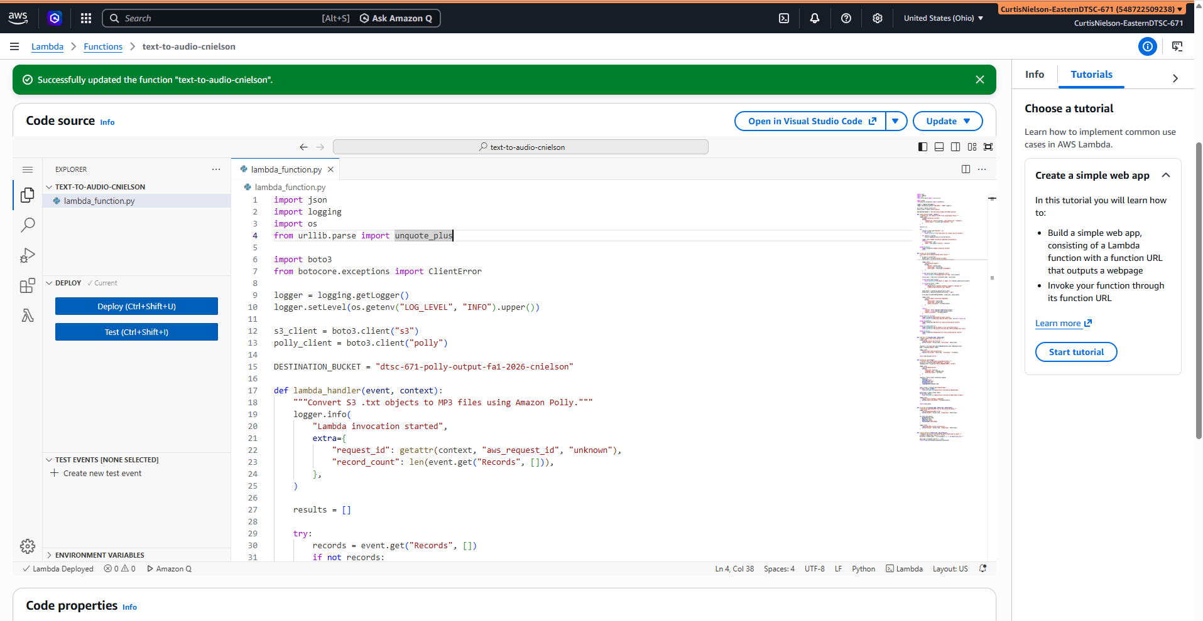

import json
import logging
import os
from urllib.parse import unquote_plus

import boto3
from botocore.exceptions import ClientError

logger = logging.getLogger()
logger.setLevel(os.getenv("LOG_LEVEL", "INFO").upper())

s3_client = boto3.client("s3")
polly_client = boto3.client("polly")

DESTINATION_BUCKET = "dtsc-671-polly-output-fa1-2026-cnielson"

def lambda_handler(event, context):
"""Convert S3 .txt objects to MP3 files using Amazon Polly."""
logger.info(
"Lambda invocation started",
extra={
"request_id": getattr(context, "aws_request_id", "unknown"),
"record_count": len(event.get("Records", [])),
},
)

results = []

try:
records = event.get("Records", [])
if not records:
raise ValueError("The event does not contain any S3 records")

for record in records:
results.append(process_s3_record(record))

logger.info("Lambda invocation completed successfully")
return {
"statusCode": 200,
"body": json.dumps({"results": results}),
}

except Exception:
logger.exception("Lambda invocation failed")
raise

def process_s3_record(record):
"""Process one S3 ObjectCreated event record."""
try:
s3_data = record["s3"]
bucket_name = s3_data["bucket"]["name"]
source_key = unquote_plus(s3_data["object"]["key"])

logger.info(
"Processing S3 object",
extra={
"bucket": bucket_name,
"source_key": source_key,
"event_name": record.get("eventName"),
},
)

if not source_key.lower().endswith(".txt"):
raise ValueError(f"Unsupported file type: {source_key}")

source_text = read_text_file(bucket_name, source_key)

if not source_text.strip():
raise ValueError(f"S3 object is empty: s3://{bucket_name}/{source_key}")

if len(source_text) > 3000:
raise ValueError(
"Amazon Polly standard synthesis supports a maximum of "
"3,000 billed characters per request"
)

audio_bytes = synthesize_speech(source_text)
output_key = replace_extension(source_key, ".mp3")

write_mp3_file(DESTINATION_BUCKET, output_key, audio_bytes)

logger.info(
"Text-to-speech conversion completed",
extra={
"source_key": source_key,
"output_key": output_key,
"audio_size_bytes": len(audio_bytes),
},
)

return {
"source": f"s3://{bucket_name}/{source_key}",
"output": f"s3://{bucket_name}/{output_key}",
"audio_size_bytes": len(audio_bytes),
}

except KeyError as error:
logger.exception("Malformed S3 event record")
raise ValueError(f"Missing required event field: {error}") from error

except ClientError:
logger.exception("AWS API error while processing S3 record")
raise

except UnicodeDecodeError:
logger.exception("The S3 object is not valid UTF-8 text")
raise ValueError("The source file must be a UTF-8 encoded text file")

except Exception:
logger.exception("Unexpected error while processing S3 record")
raise

def read_text_file(bucket_name, object_key):
"""Read a UTF-8 text file from S3."""
logger.info(
"Reading source text from S3",
extra={"bucket": bucket_name, "source_key": object_key},
)

response = s3_client.get_object(Bucket=bucket_name, Key=object_key)
body = response["Body"].read()

logger.info(
"Source text read successfully",
extra={"source_key": object_key, "size_bytes": len(body)},
)

return body.decode("utf-8")

def synthesize_speech(text):
"""Convert text to MP3 audio using Amazon Polly."""
voice_id = os.getenv("POLLY_VOICE_ID", "Joanna")
language_code = os.getenv("POLLY_LANGUAGE_CODE", "en-US")

logger.info(
"Calling Amazon Polly",
extra={
"voice_id": voice_id,
"language_code": language_code,
"character_count": len(text),
},
)

response = polly_client.synthesize_speech(
Text=text,
TextType="text",
OutputFormat="mp3",
VoiceId=voice_id,
LanguageCode=language_code,
)

audio_stream = response.get("AudioStream")
if audio_stream is None:
raise RuntimeError("Amazon Polly returned no AudioStream")

audio_bytes = audio_stream.read()
if not audio_bytes:
raise RuntimeError("Amazon Polly returned an empty audio stream")

logger.info(
"Amazon Polly synthesis completed",
extra={"audio_size_bytes": len(audio_bytes)},
)

return audio_bytes

def write_mp3_file(bucket_name, object_key, audio_bytes):
"""Write the generated MP3 file to the source S3 bucket."""
logger.info(
"Writing generated MP3 to S3",
extra={"bucket": bucket_name, "output_key": object_key},
)

s3_client.put_object(
Bucket=bucket_name,
Key=object_key,
Body=audio_bytes,
ContentType="audio/mpeg",
)

logger.info(
"Generated MP3 written successfully",
extra={"bucket": bucket_name, "output_key": object_key},
)

def replace_extension(object_key, new_extension):
"""Replace the source file extension while preserving its path."""
filename = object_key.rsplit("/", 1)[-1]
directory = object_key[: -len(filename)] if "/" in object_key else ""

base_name = filename.rsplit(".", 1)[0]
return f"{directory}{base_name}{new_extension}"

- [10 points] In the space below, provide a screenshot of two buckets (one input, one output). You can search by “polly” in S3 to have only the two polly buckets in the list.

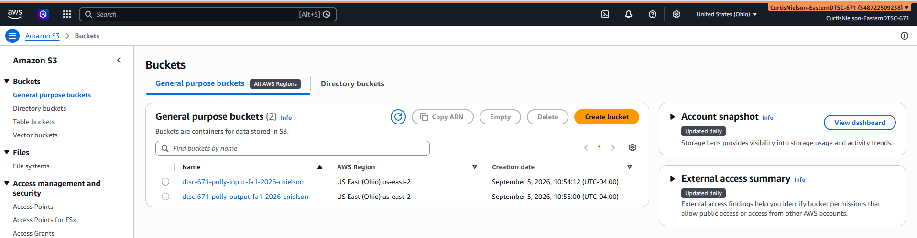

- [10 points] In the space below, provide a screenshot of the CloudWatch log streams for your Lambda function. Fit as many as you can in the screenshot.

Three attempts were required to get the desired result.

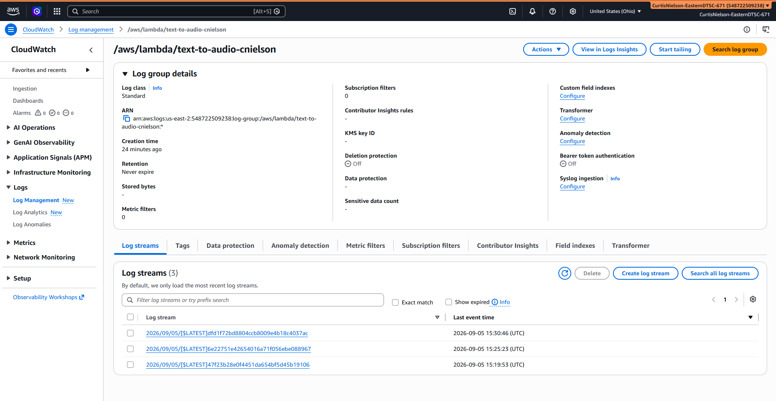

- [10 points] In the space below, provide a screenshot of the CloudWatch stream that functioned without errors.
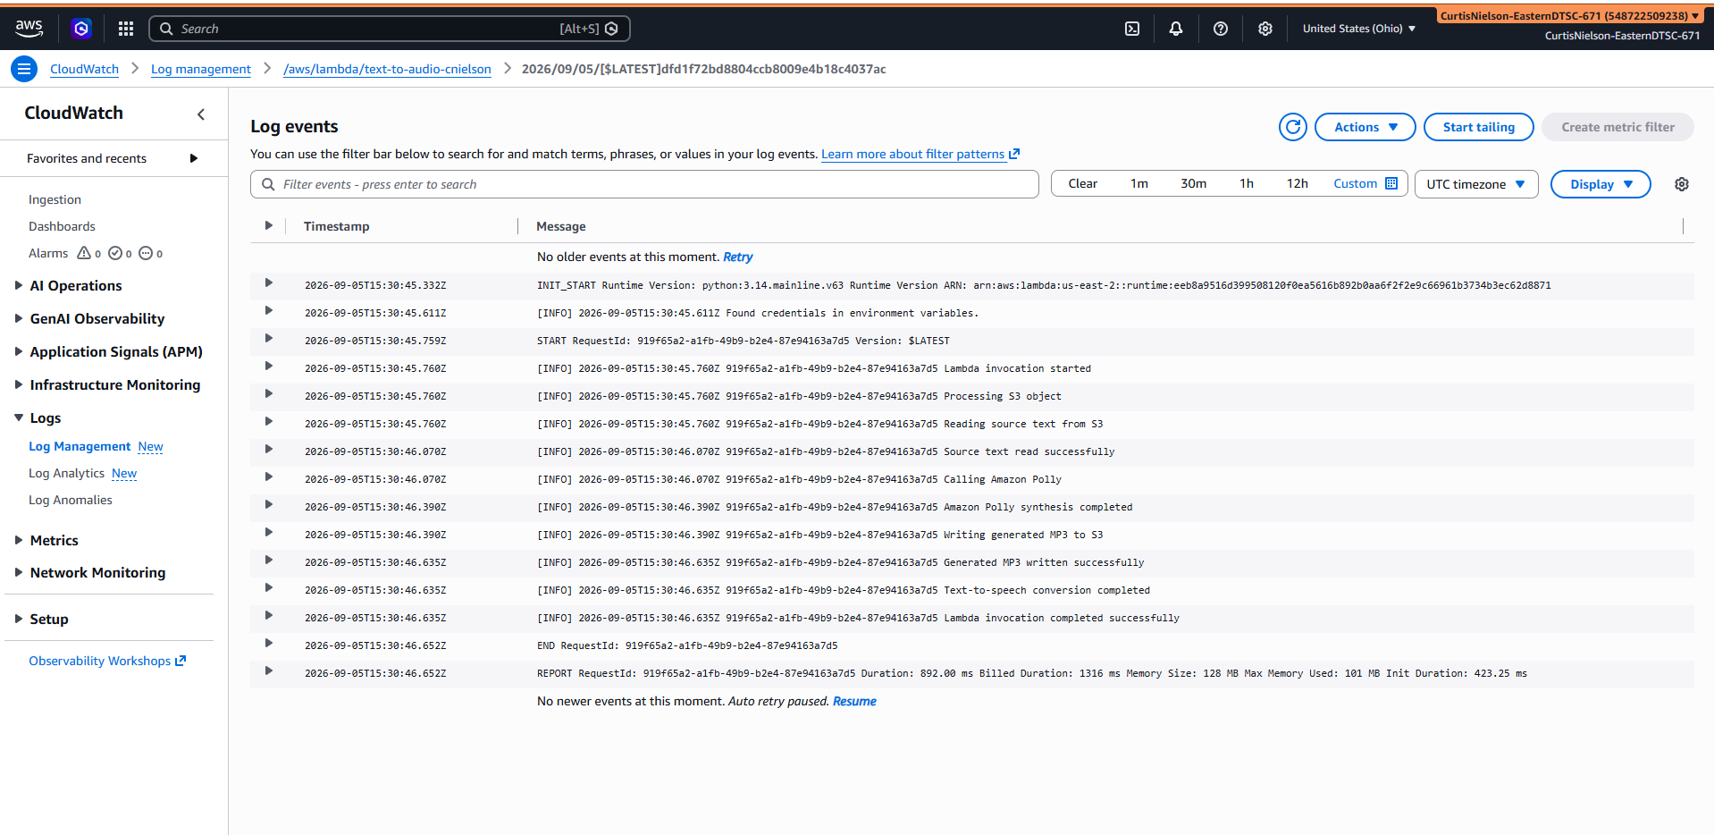

- [10 points] In the space below, provide a screenshot of IAM role permissions for the Lambda function.

The IAM execution role is text-to-audio-cnielson-role-pwosvnkk (highlighted)

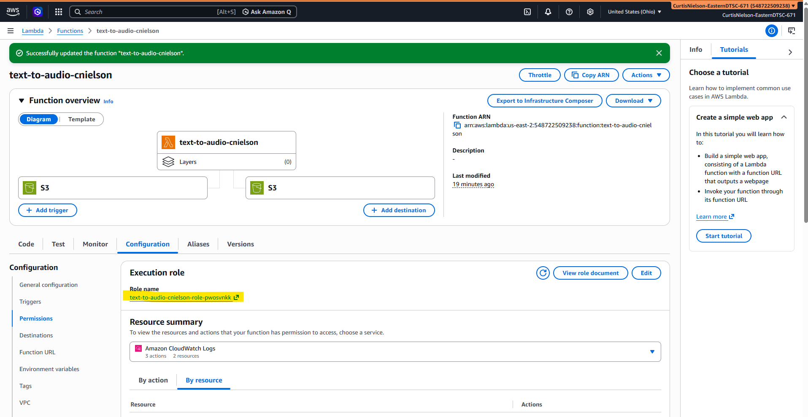

text-to-audio-cnielson-role-pwosvnkk contains the following permissions

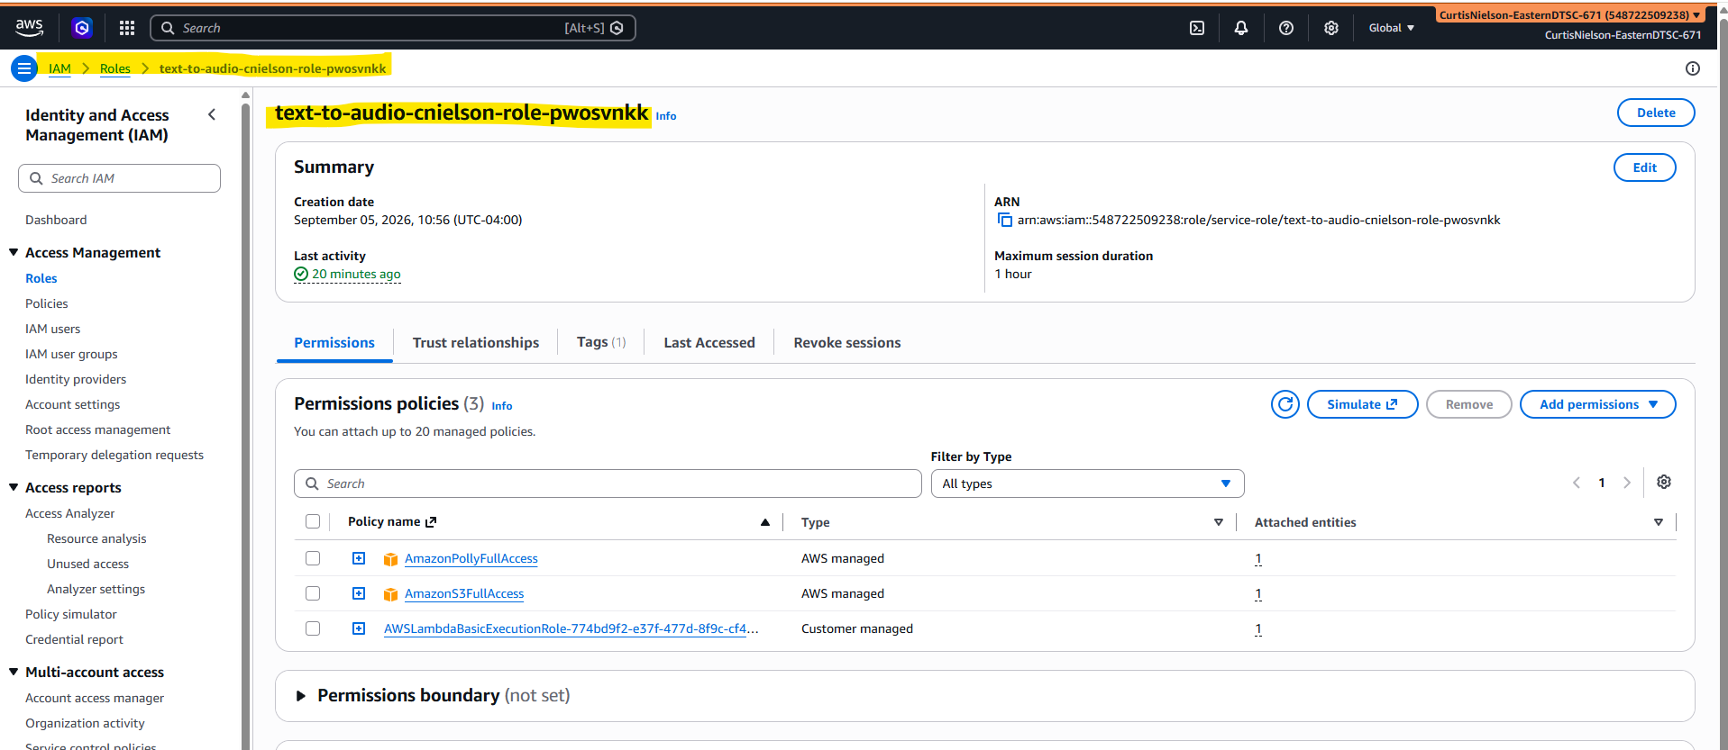

- [15 points] In the space below, provide a screenshot of the MP3 file in your output bucket.

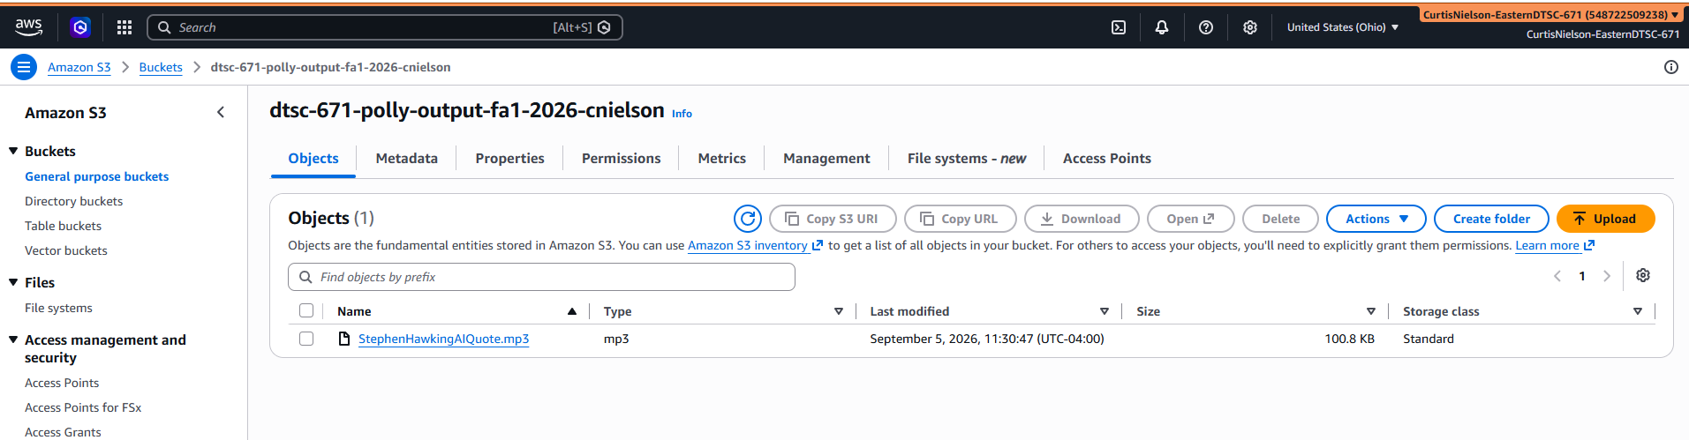

- [15 points] You will upload your MP3 to Brightspace separately.

